12576 - Nisanth Saravanan
L1 MySQL Assessmet

Online Auction System

This case study involves the design of
an online auction system that enables users to bid on items and win
auctions. The system manages auction items, bids, and winner
determination. The database schema ensures secure and transparent
management of auction processes.

Task:

- Perform W3H analysis on the given Case Study.
- Design an ERD
- Create tables for an implemented ERD
- Add primary key, foreign key, and the necessary constraints.
- Insert data into the tables (min of 7 rows)
- Generate the schema diagram (Use reverse engineering)

Documents to be submitted in PDF file format.

1.W3H doc.
2.Output Screen doc. ( ERD , Table Creation Queries , Table Data )
3. MYSQL Coding Screens.
4. And upload the Query File in Github and submit the URL.

GitHub Link:

RelevantzRIX2024/Assessments/SQL at 12576_Nisanth · benhar-velankanni/RelevantzRIX2024
W3H Analysis

Project Title: Online Auction System
What? |  | How?
1. What are the various entities needed for this database?  A: Required Entities:  a) Auction_Items  b) Bidders  c) Bids  2. What are the necessary functionalities of Auction_Items?  A: Auction_Items:  a) Store details of auction items.  b) Store the status of each item.  3. What are the necessary functionalities of Bidders?  A: Bidders:  a) Store details of Bidders.  4. What are the necessary functionalities of Bids?  A: Bids:  a) Store details of Bids.  b) Store the status of each bid. |  | 1. Auction_Items:  a) Store details of auction_items:  Method 1: Store the details in a single table.  Method 2: Divide the details into a few more tables, for example Categories as an individual relation, and make use of references.  Method 3: Store the details with non-atomic values in columns.  b) Store the status of each item:  Method 1: Store the details in the same table.  Method 2: Divide the details into a few more tables.  Method 3: Store the details with non-atomic values in columns.  2. Bidders:  a) Store the details of Bidders:  Method 1: Store the details in the same table.  Method 2: Divide the details into a few more tables.  Method 3: Store the details with non-atomic values in columns.  3. Bids:  a) Store the details of Bids:  Method 1: Store the details in the same table, using only the minimal amount of data to have a significant relation.  Method 2: Divide the details into a few more tables.  Method 3: Store the details with non-atomic values in columns.  b) Store the status of each item:  Method 1: Store the details in the same table.  Method 2: Divide the details into a few more tables.  Method 3: Store the details with non-atomic values in columns.
1. Auction_Items:  a) Store details of auction_items:  Method 2: Divide the details into a few more tables, for example Categories as an individual relation, and make use of references.  A: Provides efficient relation with sufficient normalisation.  b) Store the status of each item:  Method 2: Divide the details into a few more tables.  A: Provides efficient relation with sufficient normalisation.  2. Bidders:  a) Store the details of Bidders:  Method 1: Store the details in the same table.  A: Provides sufficient normalisation, without needing a new relation in the mix.  3. Bids:  a) Store the details of Bids:  Method 1: Store the details in the same table, using only the minimal amount of data to have a significant relation.  A: Provides sufficient normalisation, without needing a new relation in the mix.  b) Store the status of each item:  Method 2: Divide the details into a few more tables.  A: Provides efficient relation with sufficient normalisation. |  | 1. Auction_Items:  a) Store details of auction_items:  The details can be stored in a single table, but will contain at least a single column of high redundancy. And non-atomic values are inefficient to our cause.  b) Store the status of each item:  The details can be stored in a single table, but will contain at least a single column of high redundancy. And non-atomic values are inefficient to our cause.  2. Bidders:  a) Store the details of Bidders:  The need for a new relation asks for more join type quires in the future and aggregated values are a mess.  3. Bids:  a) Store the details of Bids:  The need for a new relation asks for more join type quires in the future and aggregated values are a mess.  b) Store the status of each item:  The details can be stored in a single table, but will contain at least a single column of high redundancy. And non-atomic values are inefficient to our cause.
Why? |  | Why Not?

ER Diagram:

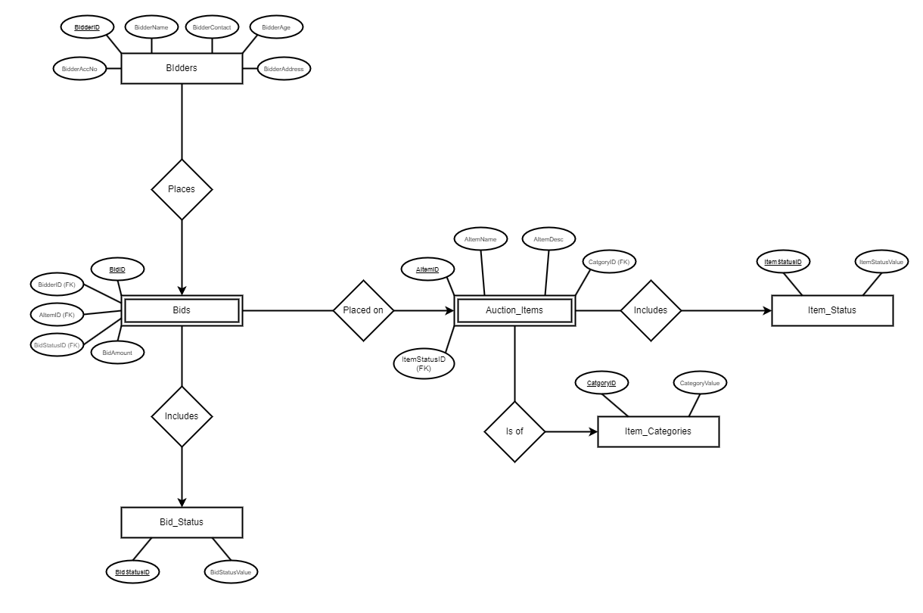

Auctions.sql

CREATE DATABASE AUCTION_HOUSE;
USE AUCTION_HOUSE;

-- ITEM STATUS TABLE:
CREATE TABLE ITEM_STATUS (
ItemStatusID INT PRIMARY KEY,
ItemStatusValue VARCHAR(50) UNIQUE
);
INSERT INTO ITEM_STATUS (ItemStatusID,ItemStatusValue)
VALUES
(1, 'SOLD'),
(0, 'UNSOLD');
SELECT
ItemStatusID 'ID', ItemStatusValue 'STATUS'
FROM
ITEM_STATUS;

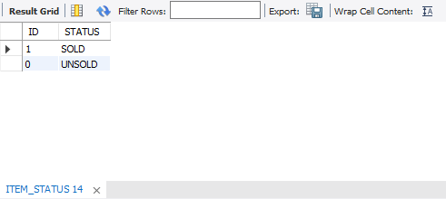

-- BID STATUS TABLE:
CREATE TABLE BID_STATUS(
BidStatusID INT PRIMARY KEY,
BidStatusValue VARCHAR(50) UNIQUE
);
INSERT INTO BID_STATUS (BidStatusID, BidStatusValue)
VALUES
(1, 'WINNER'),
(2, 'LOST'),
(3, 'PENDING');
SELECT
BidStatusID 'ID', BidStatusValue 'VALUE'
FROM
BID_STATUS;

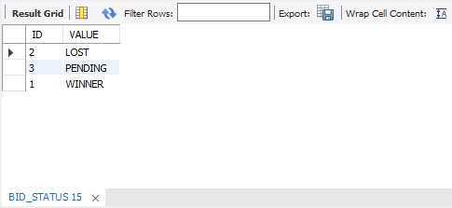
-- ITEM CATEGORIES TABLE:
CREATE TABLE ITEM_CATEGORIES(
CatgoryID INT PRIMARY KEY,
CategoryValue VARCHAR(50) UNIQUE
);
INSERT INTO ITEM_CATEGORIES (CatgoryID, CategoryValue)
VALUES
(100, 'ANTIQUES'),
(101, 'ELECTRONICS'),
(102, 'FASHION'),
(103, 'JEWELLERY'),
(104, 'ART'),
(105, 'PRE-HISTORIC'),
(106, 'HISTORIC'),
(107, 'ORIENTAL'),
(108, 'WAR MEMROBILLIA'),
(109, 'LITERATURE'),
(110, 'MISC');
SELECT
CatgoryID 'ID', CategoryValue 'CATEGORY'
FROM
ITEM_CATEGORIES;

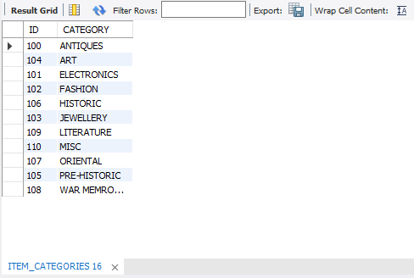
-- AUCTION ITEMS TABLE:
CREATE TABLE AUCTION_ITEMS(
AItemID INT AUTO_INCREMENT PRIMARY KEY,
AItemName VARCHAR(50),
AItemDesc VARCHAR(250),
CatgoryID INT,
ItemStatusID INT DEFAULT 0,
FOREIGN KEY (CatgoryID) REFERENCES ITEM_CATEGORIES(CatgoryID),
FOREIGN KEY (ItemStatusID) REFERENCES ITEM_STATUS(ItemStatusID)
);
INSERT INTO AUCTION_ITEMS (AItemName, AItemDesc, CatgoryID)
VALUES
('TEMPLAR KNIGHT ARMOR', 'Lorem ipsum dolor sit amet',106),
('THE OLDEST KNOWN GREEN TEA FROM THE SILK ROUTE', 'Lorem ipsum dolor sit amet',107),
('MG42 - THE LMG', 'Lorem ipsum dolor sit amet',108),
('THE FIRST COPY OF ANIMAL FARM', 'Lorem ipsum dolor sit amet',109),
('A PARCHMENT OF OLD ROYAL DECREE', 'Lorem ipsum dolor sit amet',110),
('COLLAR BONE OF A T-REX', 'Lorem ipsum dolor sit amet',105),
("DANTE'S INFERNO", 'Lorem ipsum dolor sit amet',104),
('KOHINOOR', 'Lorem ipsum dolor sit amet',103),
("HITLER'S TRENCH COAT", 'Lorem ipsum dolor sit amet',102),
('HUMMING BIRD VASE', 'Lorem ipsum dolor sit amet',100),
('THE 1ST PHONE', 'Lorem ipsum dolor sit amet',101);
SELECT
A.AItemID 'ITEM ID',
A.AItemName 'NAME',
A.AItemDesc 'DESCRIPTION',
C.CategoryValue 'CATEGORY',
S.ItemStatusValue 'STATUS'
FROM
AUCTION_ITEMS A
JOIN
ITEM_CATEGORIES C ON A.CatgoryID = C.CatgoryID
JOIN
ITEM_STATUS S ON A.ItemStatusID = S.ItemStatusID;

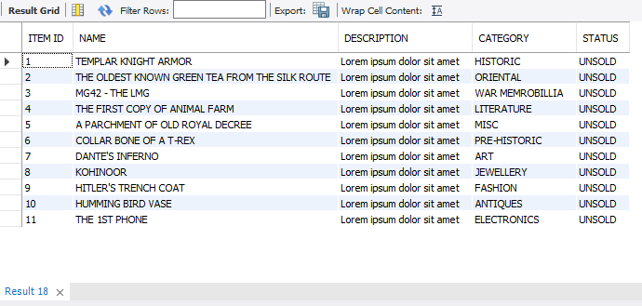
-- BIDDERS TABLE:
CREATE TABLE BIDDERS(
BidderID INT AUTO_INCREMENT PRIMARY KEY,
BidderName VARCHAR(50),
BidderContact VARCHAR(10) NOT NULL,
BidderAge INT,
BidderAddress VARCHAR(250) NOT NULL,
BidderAccNo VARCHAR(10) NOT NULL UNIQUE,
CONSTRAINT CHK_BidderContact CHECK(BidderContact REGEXP '[0-9]{10}$'),
CONSTRAINT CHK_BidderAccNo CHECK(BidderAccNo REGEXP '[0-9]{10}$'),
CONSTRAINT CHK_BidderAge CHECK(BidderAge >= 18)
);
INSERT INTO BIDDERS (BidderName, BidderContact, BidderAge, BidderAddress, BidderAccNo)
VALUES
('JHON DOE', 1234567890, 23, 'Lorem ipsum dolor sit amet', 1234567890),
('JANE DOE', 1245862350, 26, 'Lorem ipsum dolor sit amet', 1245862350),
('JENNY DOE', 7541283609, 26, 'Lorem ipsum dolor sit amet', 7541283609),
('JAKE DOE', 8965741238, 32, 'Lorem ipsum dolor sit amet', 8965741238),
('MICKEY DOE', 8452367109, 67, 'Lorem ipsum dolor sit amet', 8452367109),
('DUCKY DOE', 8541362079, 34, 'Lorem ipsum dolor sit amet', 2854136079),
('MARY DOE', 1024586325, 87, 'Lorem ipsum dolor sit amet', 1024586325);
SELECT
BidderID 'ID',
BidderName 'NAME',
BidderContact 'CONTACT',
BidderAge 'AGE',
BidderAddress 'ADDRESS',
BidderAccNo 'ACCOUNT NO'
FROM
BIDDERS;

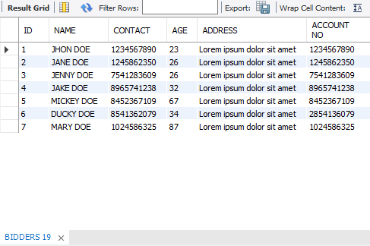
-- BIDS TABLE:
CREATE TABLE BIDS(
BidID INT AUTO_INCREMENT PRIMARY KEY,
BidderID INT,
AItemID INT,
BidStatusID INT DEFAULT 3,
BidAmount INT,
FOREIGN KEY (BidderID) REFERENCES BIDDERS(BidderID),
FOREIGN KEY (AItemID) REFERENCES AUCTION_ITEMS(AItemID),
FOREIGN KEY (BidStatusID) REFERENCES BID_STATUS(BidStatusID)
);
INSERT INTO BIDS (BidderID, AItemID, BidAmount)
VALUES
(1, 3, 50000),
(3, 4, 45000),
(7, 5, 75000),
(2, 3, 84000),
(1, 4, 96000),
(4, 5, 98000),
(6, 6, 75000),
(7, 6, 784000);
SELECT
B.BidID 'BID ID',
BD.BidderName 'BIDDER NAME',
A.AItemName 'ITEM NAME',
S.BidStatusValue 'STATUS',
B.BidAmount 'BID AMOUNT'
FROM
BIDS B
JOIN
BIDDERS BD ON B.BidderID = BD.BidderID
JOIN
AUCTION_ITEMS A ON B.AItemID = A.AItemID
JOIN
BID_STATUS S ON B.BidStatusID = S.BidStatusID;

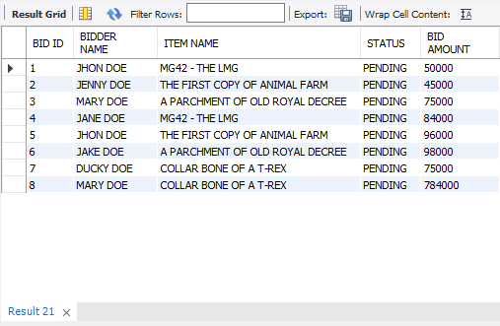
Updating values:

Before Updating:

SELECT
B.BidID 'BID ID',
BD.BidderName 'BIDDER NAME',
A.AItemName 'ITEM NAME',
S.BidStatusValue 'STATUS',
B.BidAmount 'BID AMOUNT'
FROM
BIDS B
JOIN
BIDDERS BD ON B.BidderID = BD.BidderID
JOIN
AUCTION_ITEMS A ON B.AItemID = A.AItemID
JOIN
BID_STATUS S ON B.BidStatusID = S.BidStatusID
WHERE
B.AItemID = 5
ORDER BY B.BidAmount DESC;

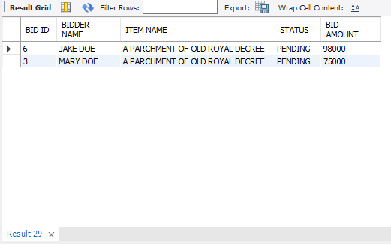
After Updating:

-- Updating the bid status of a particular bid:
SELECT
B.BidID 'BID ID',
BD.BidderName 'BIDDER NAME',
A.AItemName 'ITEM NAME',
S.BidStatusValue 'STATUS',
B.BidAmount 'BID AMOUNT'
FROM
BIDS B
JOIN
BIDDERS BD ON B.BidderID = BD.BidderID
JOIN
AUCTION_ITEMS A ON B.AItemID = A.AItemID
JOIN
BID_STATUS S ON B.BidStatusID = S.BidStatusID
WHERE
B.AItemID = 5
ORDER BY B.BidAmount DESC;
UPDATE BIDS
SET BidStatusID = 1
WHERE (AItemID = 5) AND (BidAmount = 98000);
UPDATE BIDS
SET BidStatusID = 2
WHERE (AItemID = 5) AND (BidAmount = 75000);

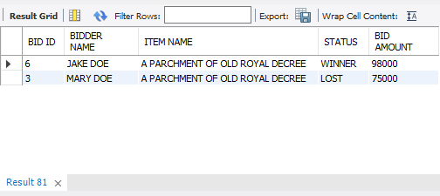
-- Updating the Item Status after sale:
UPDATE AUCTION_ITEMS
SET
ItemStatusID = 1
WHERE
AItemID = 5;

Before:

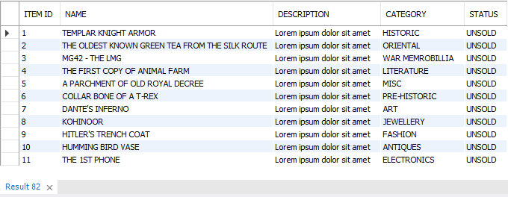

After:
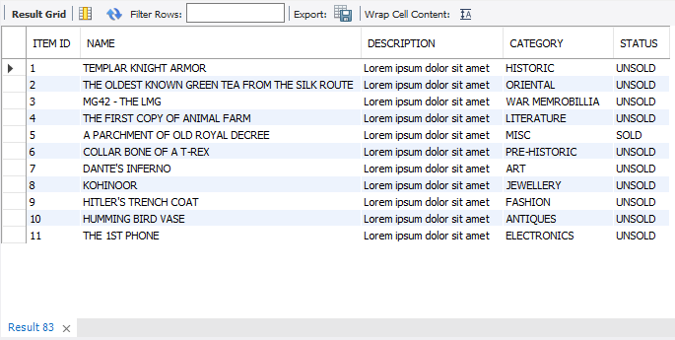
Deletion of rows:
Deletion of Concluded Bids and Deleting sold items:

Before:

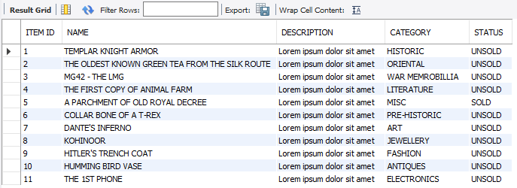

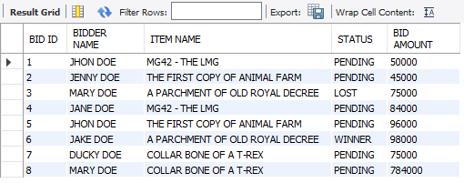

After:

-- Deletion of sold items:
DELETE FROM AUCTION_ITEMS
WHERE
ItemStatusID = 1;
-- Deletion of Concluded Bids:
DELETE FROM BIDS
WHERE
BidStatusID != 3;

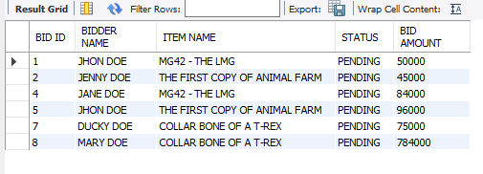

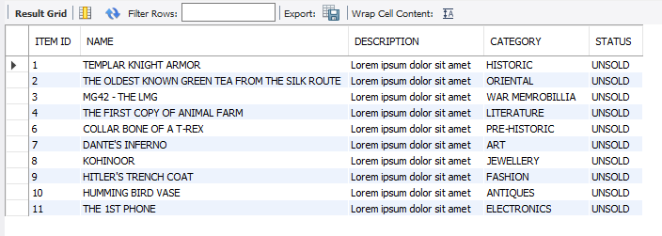

(Only the rows with sold status and rows without pending status were deleted.)
Store Procedures:

-- Store Procedure to See if an item exists:
DELIMITER //
CREATE PROCEDURE spSearchItem (IN ITEM_NAME VARCHAR(50), OUT RESULT VARCHAR(50))
BEGIN
DECLARE COUNTER INT;
SELECT
COUNT(*)
INTO COUNTER FROM
AUCTION_ITEMS
WHERE
ITEM_NAME = AItemName;
IF (COUNTER > 0) THEN
SET RESULT = 'ITEM EXISTS!';
ELSE SET RESULT = "ITEM DOESN'T EXIST!";
END IF;
END //
DELIMITER ;
CALL spSearchItem('TEMPLAR KNIGHT ARMOR', @result);
SELECT @result;

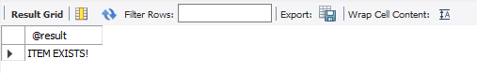
CALL spSearchItem('RANDOM GARBAGE', @result);
SELECT @result;

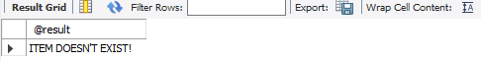
Schema Diagram:

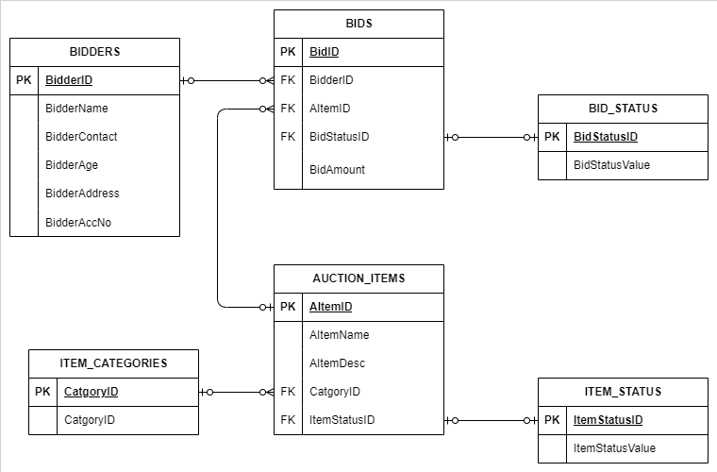

Complete SQL Code:

CREATE DATABASE AUCTION_HOUSE;
-- ----------------------------------------------------------------------------------------------------------------------------------------------------
USE AUCTION_HOUSE;
-- ----------------------------------------------------------------------------------------------------------------------------------------------------
-- ITEM STATUS TABLE:
CREATE TABLE ITEM_STATUS (
ItemStatusID INT PRIMARY KEY,
ItemStatusValue VARCHAR(50) UNIQUE
);
INSERT INTO ITEM_STATUS (ItemStatusID,ItemStatusValue)
VALUES
(1, 'SOLD'),
(0, 'UNSOLD');
SELECT
ItemStatusID 'ID', ItemStatusValue 'STATUS'
FROM
ITEM_STATUS;
-- ----------------------------------------------------------------------------------------------------------------------------------------------------
-- BID STATUS TABLE:
CREATE TABLE BID_STATUS(
BidStatusID INT PRIMARY KEY,
BidStatusValue VARCHAR(50) UNIQUE
);
INSERT INTO BID_STATUS (BidStatusID, BidStatusValue)
VALUES
(1, 'WINNER'),
(2, 'LOST'),
(3, 'PENDING');
SELECT
BidStatusID 'ID', BidStatusValue 'VALUE'
FROM
BID_STATUS;
-- ----------------------------------------------------------------------------------------------------------------------------------------------------
-- ITEM CATEGORIES TABLE:
CREATE TABLE ITEM_CATEGORIES(
CatgoryID INT PRIMARY KEY,
CategoryValue VARCHAR(50) UNIQUE
);
INSERT INTO ITEM_CATEGORIES (CatgoryID, CategoryValue)
VALUES
(100, 'ANTIQUES'),
(101, 'ELECTRONICS'),
(102, 'FASHION'),
(103, 'JEWELLERY'),
(104, 'ART'),
(105, 'PRE-HISTORIC'),
(106, 'HISTORIC'),
(107, 'ORIENTAL'),
(108, 'WAR MEMROBILLIA'),
(109, 'LITERATURE'),
(110, 'MISC');
SELECT
CatgoryID 'ID', CategoryValue 'CATEGORY'
FROM
ITEM_CATEGORIES;
-- ----------------------------------------------------------------------------------------------------------------------------------------------------
-- AUCTION ITEMS TABLE:
CREATE TABLE AUCTION_ITEMS(
AItemID INT AUTO_INCREMENT PRIMARY KEY,
AItemName VARCHAR(50),
AItemDesc VARCHAR(250),
CatgoryID INT,
ItemStatusID INT DEFAULT 0,
FOREIGN KEY (CatgoryID) REFERENCES ITEM_CATEGORIES(CatgoryID),
FOREIGN KEY (ItemStatusID) REFERENCES ITEM_STATUS(ItemStatusID)
);
INSERT INTO AUCTION_ITEMS (AItemName, AItemDesc, CatgoryID)
VALUES
('TEMPLAR KNIGHT ARMOR', 'Lorem ipsum dolor sit amet',106),
('THE OLDEST KNOWN GREEN TEA FROM THE SILK ROUTE', 'Lorem ipsum dolor sit amet',107),
('MG42 - THE LMG', 'Lorem ipsum dolor sit amet',108),
('THE FIRST COPY OF ANIMAL FARM', 'Lorem ipsum dolor sit amet',109),
('A PARCHMENT OF OLD ROYAL DECREE', 'Lorem ipsum dolor sit amet',110),
('COLLAR BONE OF A T-REX', 'Lorem ipsum dolor sit amet',105),
("DANTE'S INFERNO", 'Lorem ipsum dolor sit amet',104),
('KOHINOOR', 'Lorem ipsum dolor sit amet',103),
("HITLER'S TRENCH COAT", 'Lorem ipsum dolor sit amet',102),
('HUMMING BIRD VASE', 'Lorem ipsum dolor sit amet',100),
('THE 1ST PHONE', 'Lorem ipsum dolor sit amet',101);
SELECT
A.AItemID 'ITEM ID',
A.AItemName 'NAME',
A.AItemDesc 'DESCRIPTION',
C.CategoryValue 'CATEGORY',
S.ItemStatusValue 'STATUS'
FROM
AUCTION_ITEMS A
JOIN
ITEM_CATEGORIES C ON A.CatgoryID = C.CatgoryID
JOIN
ITEM_STATUS S ON A.ItemStatusID = S.ItemStatusID;
-- ----------------------------------------------------------------------------------------------------------------------------------------------------
-- BIDDERS TABLE:
CREATE TABLE BIDDERS(
BidderID INT AUTO_INCREMENT PRIMARY KEY,
BidderName VARCHAR(50),
BidderContact VARCHAR(10) NOT NULL,
BidderAge INT,
BidderAddress VARCHAR(250) NOT NULL,
BidderAccNo VARCHAR(10) NOT NULL UNIQUE,
CONSTRAINT CHK_BidderContact CHECK(BidderContact REGEXP '[0-9]{10}$'),
CONSTRAINT CHK_BidderAccNo CHECK(BidderAccNo REGEXP '[0-9]{10}$'),
CONSTRAINT CHK_BidderAge CHECK(BidderAge >= 18)
);
INSERT INTO BIDDERS (BidderName, BidderContact, BidderAge, BidderAddress, BidderAccNo)
VALUES
('JHON DOE', 1234567890, 23, 'Lorem ipsum dolor sit amet', 1234567890),
('JANE DOE', 1245862350, 26, 'Lorem ipsum dolor sit amet', 1245862350),
('JENNY DOE', 7541283609, 26, 'Lorem ipsum dolor sit amet', 7541283609),
('JAKE DOE', 8965741238, 32, 'Lorem ipsum dolor sit amet', 8965741238),
('MICKEY DOE', 8452367109, 67, 'Lorem ipsum dolor sit amet', 8452367109),
('DUCKY DOE', 8541362079, 34, 'Lorem ipsum dolor sit amet', 2854136079),
('MARY DOE', 1024586325, 87, 'Lorem ipsum dolor sit amet', 1024586325);
SELECT
BidderID 'ID',
BidderName 'NAME',
BidderContact 'CONTACT',
BidderAge 'AGE',
BidderAddress 'ADDRESS',
BidderAccNo 'ACCOUNT NO'
FROM
BIDDERS;
-- ----------------------------------------------------------------------------------------------------------------------------------------------------
-- BIDS TABLE:
CREATE TABLE BIDS(
BidID INT AUTO_INCREMENT PRIMARY KEY,
BidderID INT,
AItemID INT,
BidStatusID INT DEFAULT 3,
BidAmount INT,
FOREIGN KEY (BidderID) REFERENCES BIDDERS(BidderID),
FOREIGN KEY (AItemID) REFERENCES AUCTION_ITEMS(AItemID),
FOREIGN KEY (BidStatusID) REFERENCES BID_STATUS(BidStatusID)
);
INSERT INTO BIDS (BidderID, AItemID, BidAmount)
VALUES
(1, 3, 50000),
(3, 4, 45000),
(7, 5, 75000),
(2, 3, 84000),
(1, 4, 96000),
(4, 5, 98000),
(6, 6, 75000),
(7, 6, 784000);
SELECT
B.BidID 'BID ID',
BD.BidderName 'BIDDER NAME',
A.AItemName 'ITEM NAME',
S.BidStatusValue 'STATUS',
B.BidAmount 'BID AMOUNT'
FROM
BIDS B
JOIN
BIDDERS BD ON B.BidderID = BD.BidderID
JOIN
AUCTION_ITEMS A ON B.AItemID = A.AItemID
JOIN
BID_STATUS S ON B.BidStatusID = S.BidStatusID;
-- ----------------------------------------------------------------------------------------------------------------------------------------------------
-- Updating the bid status of a particular bid:
SELECT
B.BidID 'BID ID',
BD.BidderName 'BIDDER NAME',
A.AItemName 'ITEM NAME',
S.BidStatusValue 'STATUS',
B.BidAmount 'BID AMOUNT'
FROM
BIDS B
JOIN
BIDDERS BD ON B.BidderID = BD.BidderID
JOIN
AUCTION_ITEMS A ON B.AItemID = A.AItemID
JOIN
BID_STATUS S ON B.BidStatusID = S.BidStatusID
WHERE
B.AItemID = 5
ORDER BY B.BidAmount DESC;
UPDATE BIDS
SET
BidStatusID = 1
WHERE
(AItemID = 5) AND (BidAmount = 98000);
UPDATE BIDS
SET
BidStatusID = 2
WHERE
(AItemID = 5) AND (BidAmount = 75000);
-- ----------------------------------------------------------------------------------------------------------------------------------------------------
-- Updating the Item Status after sale:
UPDATE AUCTION_ITEMS
SET
ItemStatusID = 1
WHERE
AItemID = 5;
-- ----------------------------------------------------------------------------------------------------------------------------------------------------
-- Deletion of sold items:
DELETE FROM AUCTION_ITEMS
WHERE
ItemStatusID = 1;
-- Deletion of Concluded Bids:
DELETE FROM BIDS
WHERE
BidStatusID != 3;
-- ----------------------------------------------------------------------------------------------------------------------------------------------------

-- Store Procedure to See if an item exists:
DELIMITER //
CREATE PROCEDURE spSearchItem (IN ITEM_NAME VARCHAR(50), OUT RESULT VARCHAR(50))
BEGIN
DECLARE COUNTER INT;
SELECT
COUNT(*)
INTO COUNTER FROM
AUCTION_ITEMS
WHERE
ITEM_NAME = AItemName;
IF (COUNTER > 0) THEN
SET RESULT = 'ITEM EXISTS!';
ELSE SET RESULT = "ITEM DOESN'T EXIST!";
END IF;
END //
DELIMITER ;
CALL spSearchItem('TEMPLAR KNIGHT ARMOR', @result);
SELECT @result;
CALL spSearchItem('RANDOM GARBAGE', @result);
SELECT @result;
-- ----------------------------------------------------------------------------------------------------------------------------------------------------

